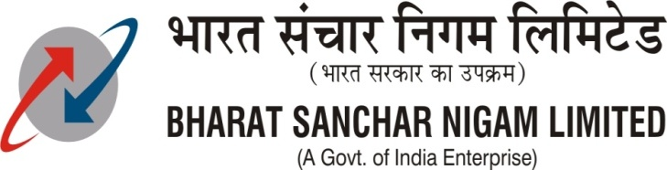Office of the Chief General Manager
Tamilnadu Circle,
No. 80, Anna Salai,
Chennai – 600 002.
Tel:- 044-28520005
FAX:-044-28520484

To
1.All SSA Heads
BSNL,Tamilnadu Circle.
2.DGM(IP TAX), Chennai

No.OP/12-140/2013/ dated at Chennai-2. the 11.01-2013.
Sub: Barring of calls to Private Operators in Tamilnadu Circle from
Office/Residential service connections.-Reg.

The following instructions may be carried out in all Local switches/ TDM/IP TAX.
I. Barring of Land line calls from service Telephone connections of BSNL to fixed network of all private operators.:
All local switches (OCB,EWSD,AXE,5 ESS,CDOT MBM and CDOT NGN) in Tamilnadu circle may bar calls originating from office/residential service category subscribers to all levels of private operators in Tamilnadu circle by blocking them in necessary route analysis table.
For CDOT NGN at Katpadi, in consultation with CDOT, the above barring of private operator calls may be carried out.
II.Barring of Land line calls from BSNL service connections to mobile network of all private operators :
- All local switches (OCB,EWSD,AXE,5 ESS,CDOT MBM &CDOT NGN ) in Tamilnadu circle should create a separate trunk group towards TDM TAX/IP TAX (incase of IP TAX, via separate DAS) and route all mobile calls, including BSNL mobile levels, originating from office/residential service category subscribers.
- The respective TDM/IP TAX(soft switch at Coimbatore and Chennai), on receipt of mobile calls on the separate Trunk groups created for the above purpose, will allow only BSNL LRN for further routing and block all LRNs of private operators.
III.Testing :
Testing on above barring of Land line /Mobile calls from BSNL service connections may be done in all local switches/TDM & IP TAX.
IV.Compliance:
a. All DE(TAX) report compliance in respect of above I&II for all Local switches,TDM /TAX/IP TAX in Tamilnadu circle.
b. DE(IP TAX),Chennai will report compliance in respect of II above for mobile calls from the dependant stations in Tamilnadu circle.
The above compliance may please be sent to this office on or before
21-01-2013.

Sd/…………..
General Manager(NWO-CFA)
O/o CGM,TN Circle,BSNL,Chennai-2.

